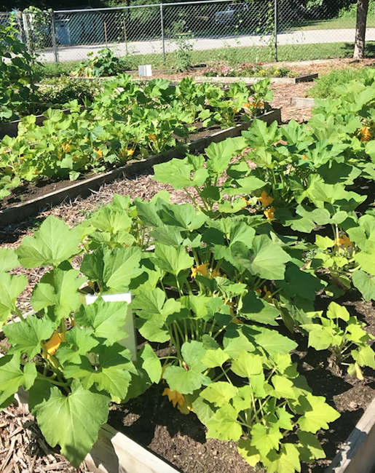  What will be available at the site?  The garden site is a fenced area with water supply, hoses, all raised beds, handicapped beds, storage shed, a compost pile and mulch pile.  There will be also be a variety of garden tools available for sharing located in the sheds.  Will there be any technical assistance?  A community Garden Assistant will be available on a regular basis. The hours will be posted at the garden. Master Gardner volunteers from Cooperative Extension will also provide gardening assistance. | Where can I get information?  Gene Riddle, Garden Manager 252-814-5110 generiddle@214@gmail.com  David Jones, Assistant Manager 252-747-5683 readysetwalk10@gmail.com  Greene County Cooperative Extension 252-747-5831 http://greene.ces.ncsu.edu  Made possible through support from: | G  Greene Community Garden  - “Inspiring Community Involvement”
What is a Community Garden?  An area of land that is made available to members of a community to grow vegetables, flowers, etc. Plots of land are leased to the gardeners for a small annual fee of $15 a year.  Where is the garden located?  The garden is located at 212 Hart Street which is off Harper Street (903S) just past the Lenoir Community College.  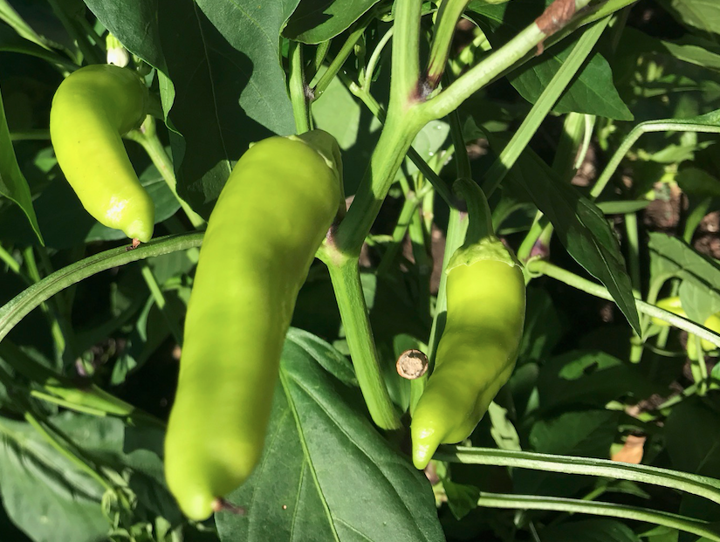 | What are the goals of the Community Garden?  To provide Greene County residents the opportunity to grow their own vegetables.  To encourage citizens to increase physical activity and make healthy food choices.  To provide gardening workshops for both children and adults.  To have fun.  To provide intergenerational gardening experience for students and adults.  To support the nutritional needs of others through contributing produce to the food shelter and volunteering 4-5 hours to help maintain the common garden areas. | 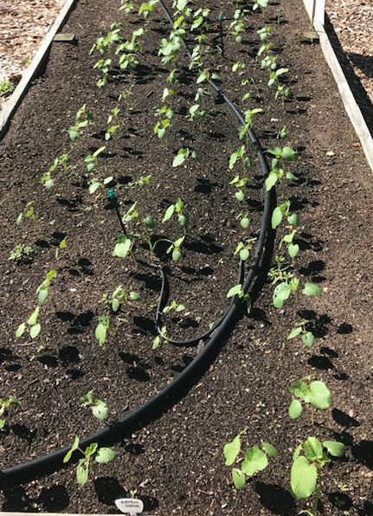  How can I be involved?  Rent a plot: Volunteer to help in the garden Make a donation Donate tools Plot Fees: 4’ X 16’ Raised Bed (64 sq. ft.) Fee: $15.00 A one-time $10.00 deposit will also be collected. It will be returned upon completing of fall clean-up to any gardener who is not returning the following year. For a full set of guidelines see the Community Garden Application form at the Greene County Extension Office: 229 Kingold Blvd., Suite E, Snow Hill, NC 28580 252-747-5831

